- At the margin, it's possible that the UK government's decision to fund higher defence spending through cuts to the foreign aid budget will provide some extra breathing space against its borrowing rule. But if NATO requires members to raise defence spending to 3% of GDP, a bigger rethink of the fiscal approach appears inevitable.
- Ofgem's announcement that the energy price cap will rise by 6.4% in April was in line with our expectations. The turnaround in the contribution of the energy category over the past six months is a key reason why inflation will rise back above 3% in April and increase further in the summer.
Prime Minister Keir Starmer made his first visit to Washington to meet President Trump this week, and as a precursor to the trip he sought to address one of Trump's key criticisms of European countries, namely that they don’t spend enough on defence. Data for 2024 showed the UK spending 2.3% of GDP on defence. While this is more than the NATO target of 2% and some way above the European average, it lags well behind the amount spent by the US (Chart 1).
Starmer announced that the UK will increase its spending to 2.5% of GDP by 2027 and maintain it at that level for the remainder of the parliament. Given the challenges associated with the public finances, he said this will be financed by cutting spending on international aid by a similar amount.
As we argued in a note published this week, this switch could potentially provide the Chancellor with a bit more breathing space against her fiscal rules, depending on how the spending changes are allocated between current and capital spending. Defence spending is typically more capital-intensive than the average department. If cuts to the aid budget are focused on day-to-day spending, this would mean a net cut to current spending and – all else equal – an improvement in the current budget. Detailed spending plans will wait for the summer's Spending Review. But if the changes do indeed imply a tilt towards capital spending, there may be a temptation to adjust the spending totals for the Office for Budget Responsibility's upcoming forecast update, particularly if the OBR makes unfavourable revisions elsewhere.
Chart 1: The UK's spending on defence is above the NATO target but well below US levels
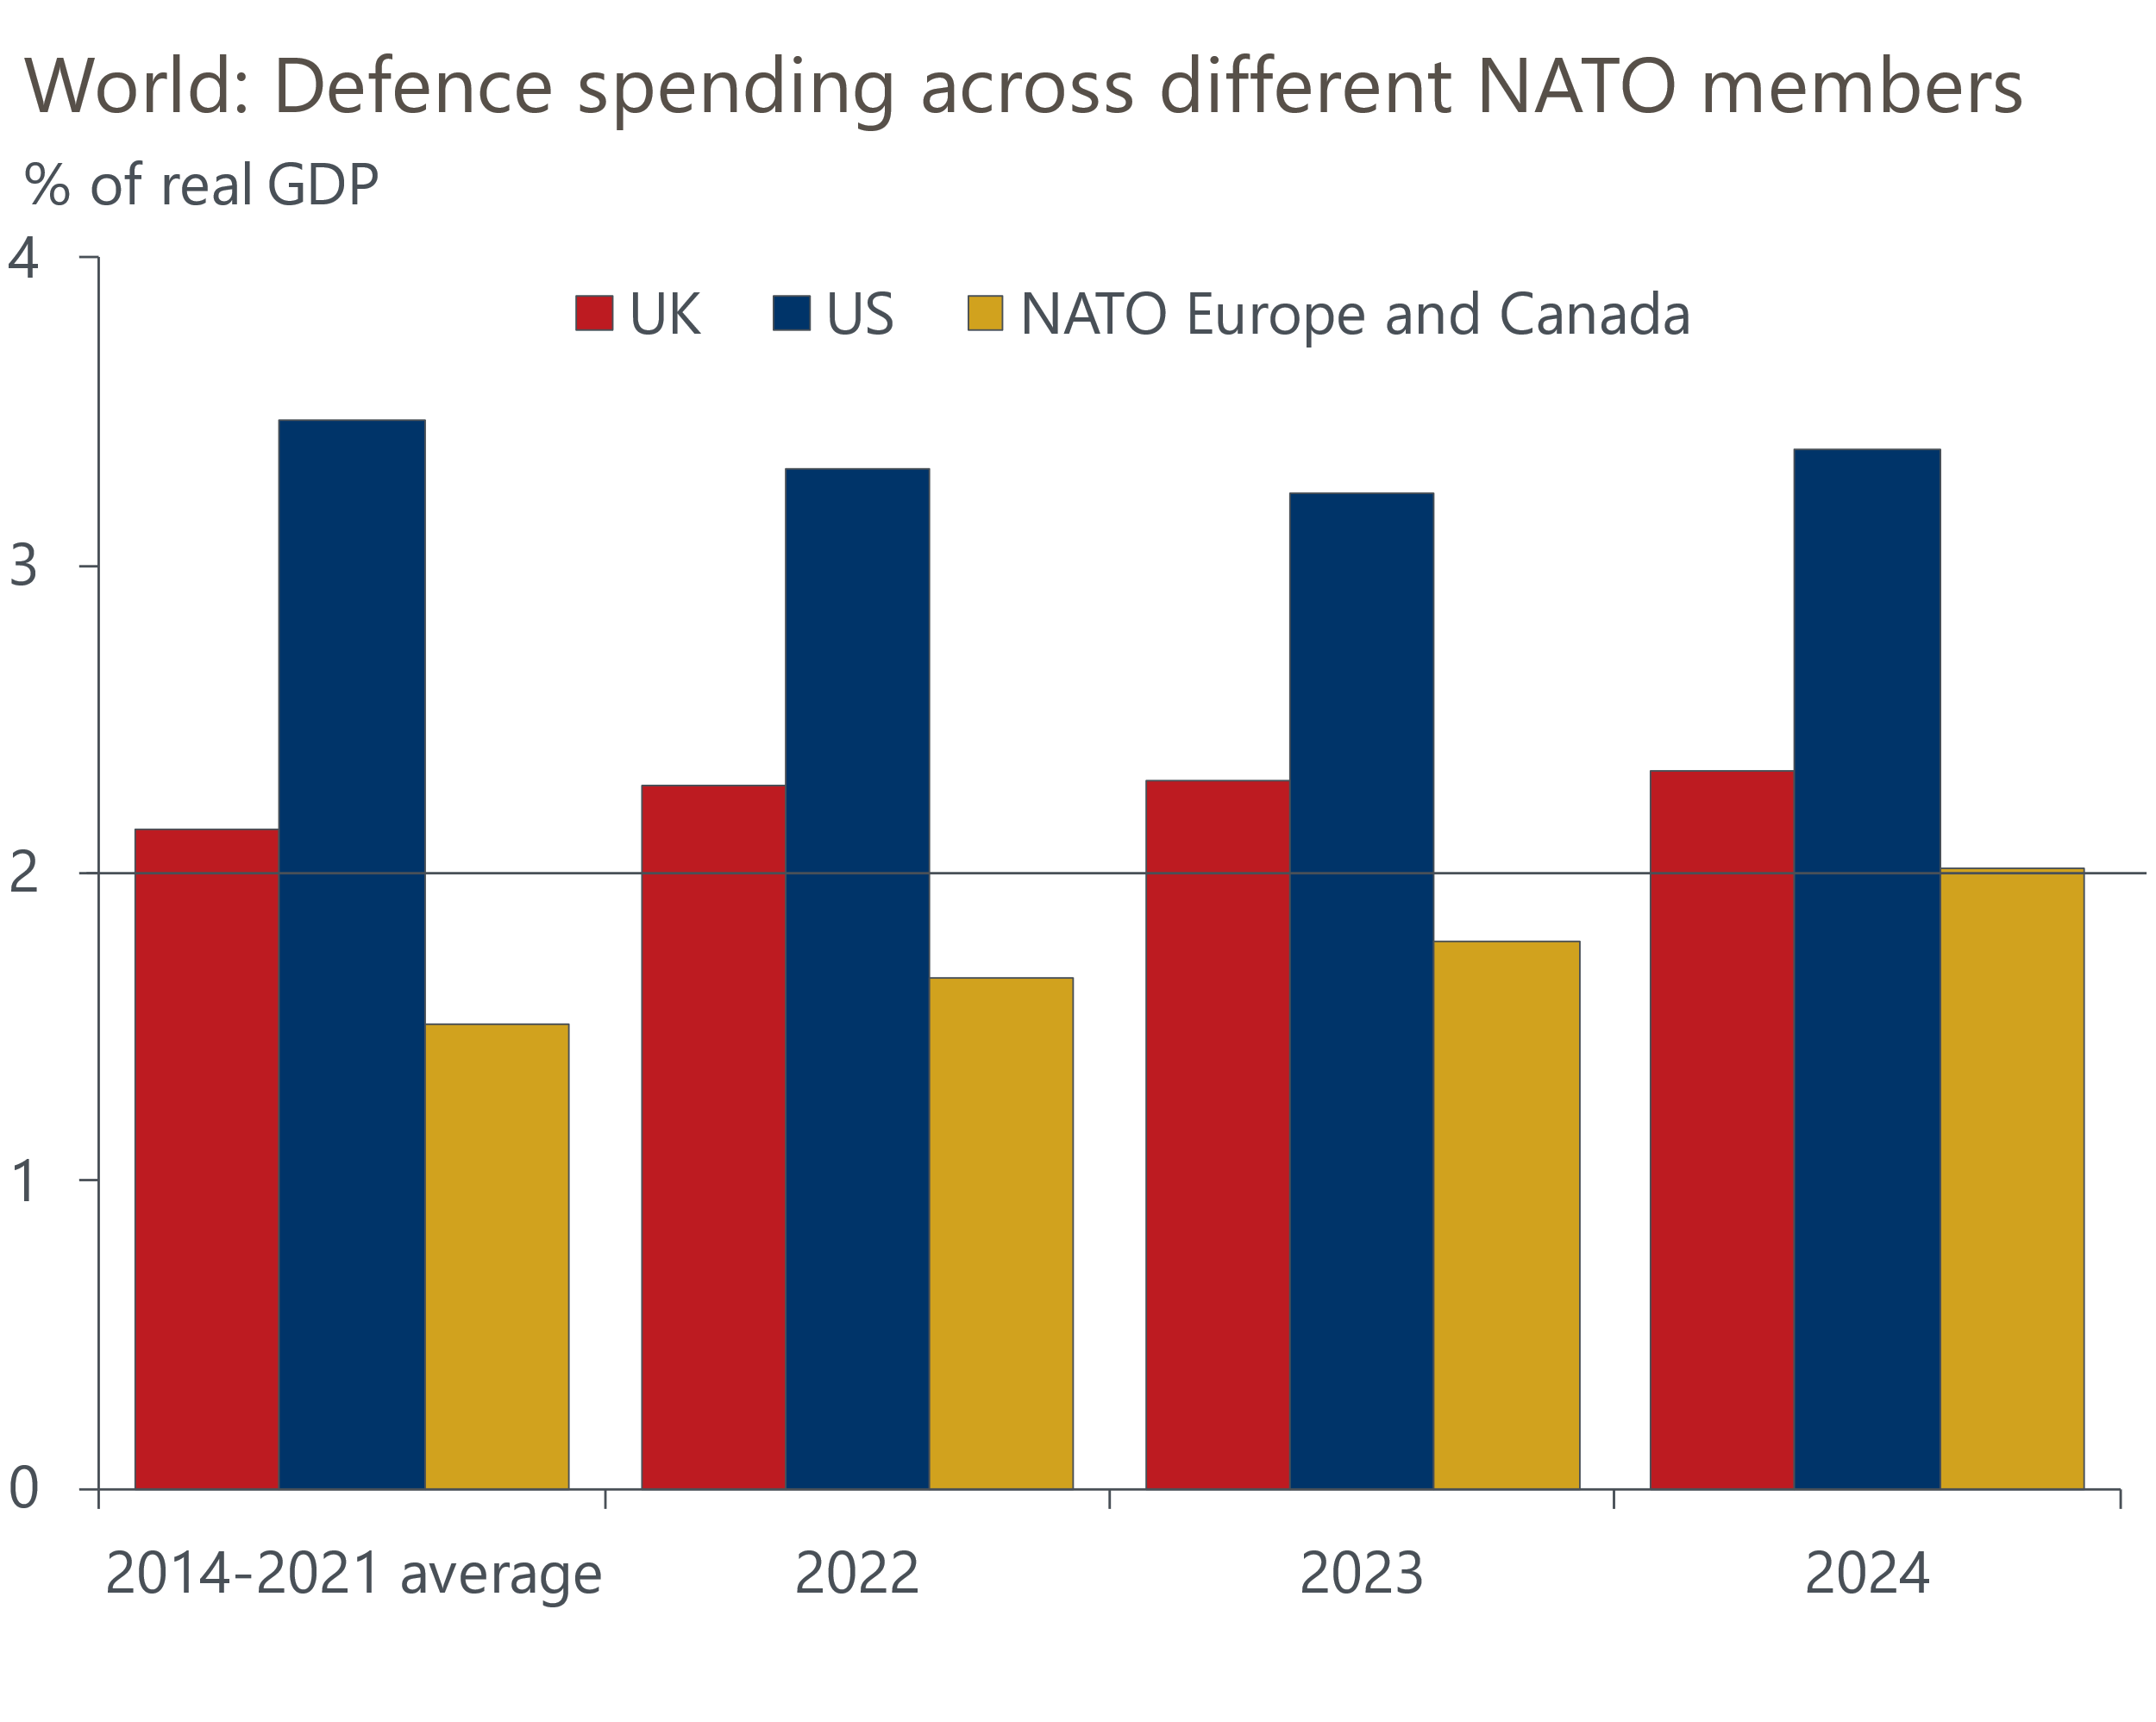
Source: NATO

But there remains a significant risk that spending 2.5% of GDP on defence won't be enough. Though President Trump's demand that NATO members commit 5% of GDP to defence spending is unlikely to be adopted, there's a good chance that NATO leaders will agree to lift the defence spending target at their June summit. Indeed, NATO Secretary General Mark Rutte recently remarked that members will have to boost defence spending to "considerably more than 3%".
An increase to 3% of GDP would require the government to spend another 0.5% of GDP or £17bn in 2029-2030, nearly double the Chancellor's current headroom against her borrowing rule. If the government must commit to such a large uplift in defence spending, then it will inevitably require a more comprehensive overhaul of the government's approach to fiscal policy. The government's reluctance to go back on manifesto commitments or to further increase the tax burden on business leaves it with relatively few revenue levers to pull. So government spending – both in terms of other departments and areas like welfare spending – seems likely to bear the bulk of the burden of any further savings.
It's been a week largely devoid of economic data, with just a handful of business surveys published. But a news development with important implications for the near-term economic outlook was the announcement of Ofgem's new energy price cap. The default price cap will increase by 6.4% to £1,849 in April, largely due to the increase in wholesale gas prices during the winter.
The rise in the price cap was in line with our expectations, so the announcement will not trigger any changes to our baseline forecast. But it does underline that we will see a substantial increase in the contribution of the energy category to inflation in April. As recently as September, energy was exerting a drag of 0.9ppts on the headline rate. But we expect the category to contribute 0.3ppts to CPI inflation in April. With the average water bill due to rise 26% that month and an array of other annual price rises coming into effect, there's a lot of uncertainty over where inflation will land. But we think the CPI rate is almost certain to rise back above 3%, after temporarily falling in February.
The good news is that wholesale gas prices have dropped back in recent weeks. Though it's very early days for the new observation window, if wholesale prices remained at their current level, they would be around 8% lower than the average of the previous window (Chart 2). That prices stay close to their current level looks a reasonable assumption given our commodities team expects warmer temperatures to cool demand.
Chart 2: Wholesale gas prices have dropped back at the start of the new observation period
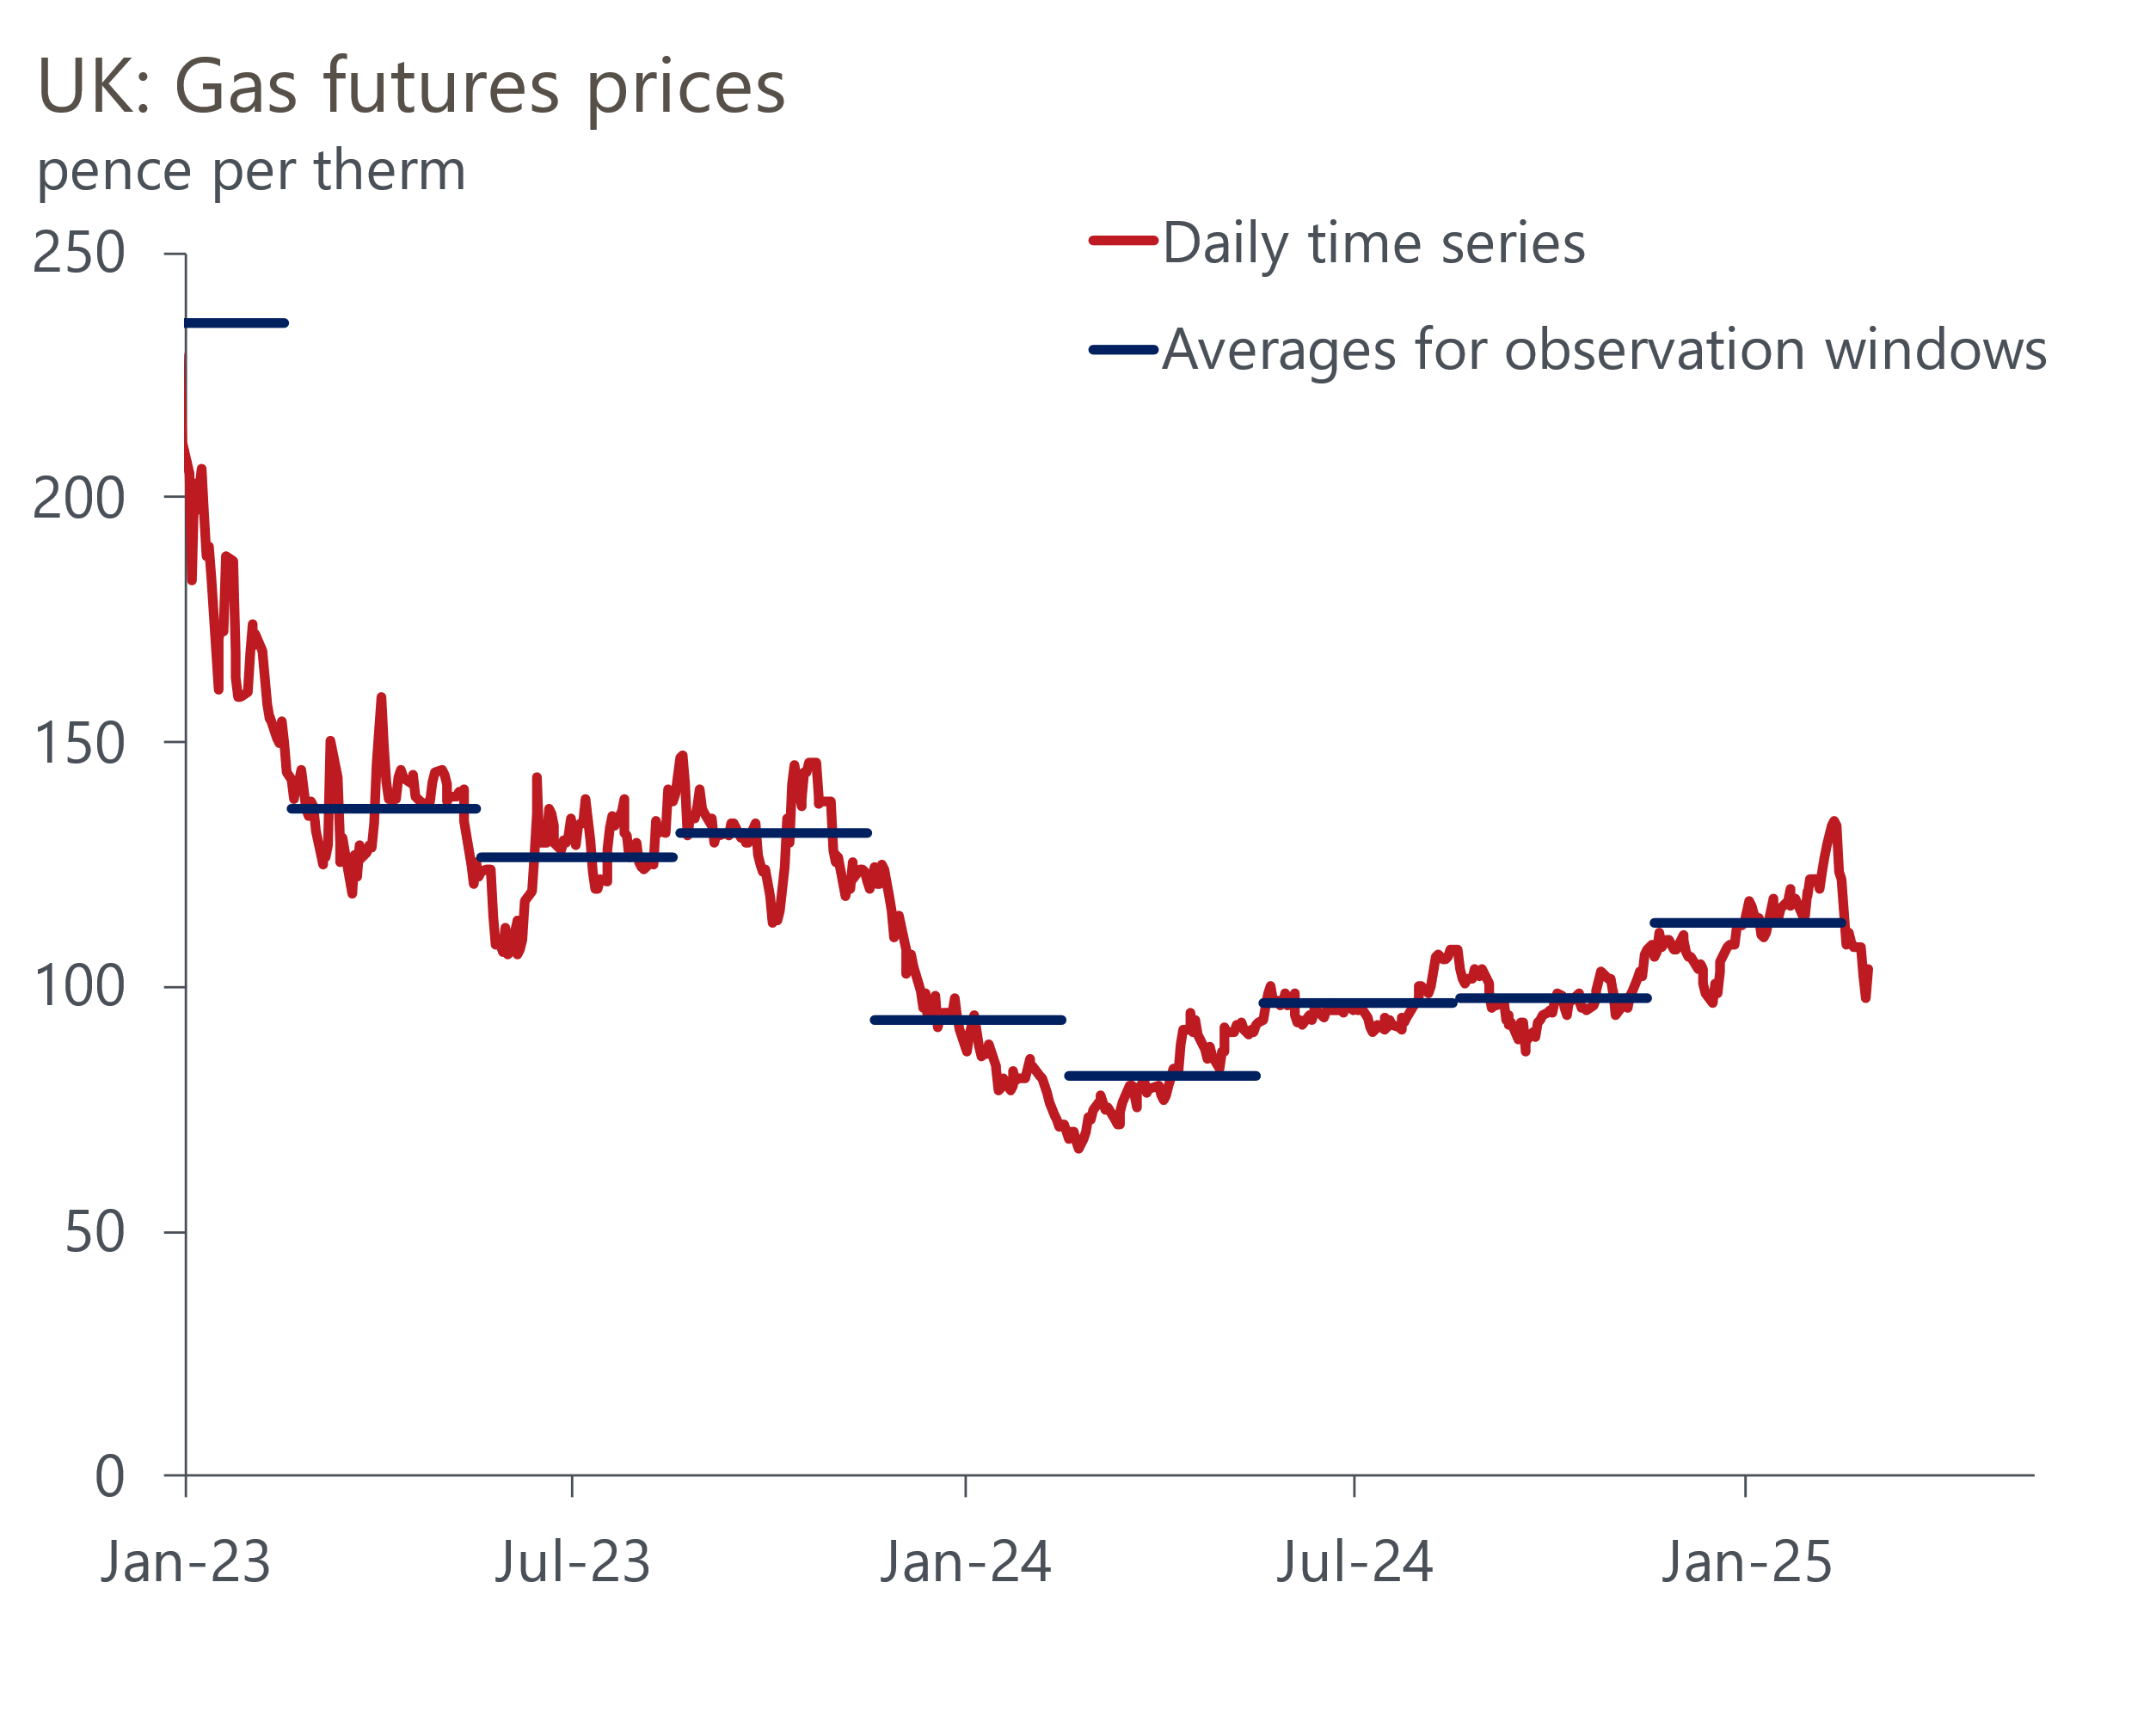
Source: Haver Analytics
The drop in electricity prices has been smaller, while wholesale prices only account for roughly half of the price cap, so the fall in Ofgem's price cap in July is on track to be lower at around 3%-4%. This would be around half of the drop seen last July, so the contribution of the energy category to inflation will keep rising. Though not our baseline forecast, a reading of 4% for CPI inflation in the autumn is a plausible scenario. We plan to publish a Research Briefing looking at the inflation outlook in more detail shortly.

The week ahead
In recent months, mortgage demand has been boosted by buyers looking to transact before the temporary increase in stamp duty thresholds expires in March. But, given the amount of time it takes to complete a purchase, we think the peak impact of this effect has now passed and that we're likely to see some payback in Q1. We expect mortgage approvals to have fallen to 65,500 in January from 66,500 in December.
However, the lagged impact of the earlier increase in approvals will mean gross mortgage lending continues to rise in Q1, as those transactions are completed. We forecast that net mortgage lending rose to £3.7bn in January.
Net unsecured lending edged up in December and we expect the recovery continued in January. Though we think gross lending probably edged down, the repayment rate was exceptionally high in December, and we expect to see some normalisation. We estimate that net consumer credit was £1.2bn in January, up from £1bn in December.
February's flash S&P Global survey reported little movement in the PMIs, with the composite and services balances just above the 50 'no change' mark and the manufacturing sector stuck deep in contractionary territory. Next week's final surveys are likely to confirm that picture and will reveal whether January's plunge in the construction PMI was a blip – as we anticipate – or the start of a more prolonged downturn.
Table 1: Week ahead calendar
Date | Events | Period | Measure | Unit | Previous | Forecast
Mar 3 | Mortgage approvals | Jan | Level | 000s | 66.5 | 65.5
Mar 3 | Mortgage lending | Jan | Net lending | £bn | 3.6 | 3.7
Mar 3 | Consumer credit | Jan | Net lending | £bn | 1.0 | 1.2
Mar 3 | S&P Global manufacturing | Feb | PMI | % bal | 46.4 | 46.4
Mar 5 | S&P Global services | Feb | PMI | % bal | 51.1 | 51.1
Mar 5 | S&P Global composite | Feb | PMI | % bal | 50.5 | 50.5
Mar 6 | S&P Global construction | Feb | PMI | % bal | 48.1 | 51.0
Source: Oxford Economics

Key forecasts
Table 2: UK forecast overview
(Annual percentage changes unless specified)
 | 2022 | 2023 | 2024 | 2025 | 2026 | 2027
GDP | 4.8 | 0.4 | 0.9 | 1.0 | 1.5 | 1.7
Private consumption | 7.3 | 0.4 | 0.7 | 1.3 | 1.4 | 1.5
Fixed investment | 5.1 | 0.3 | 1.3 | 0.1 | 3.2 | 2.5
Government consumption | 0.6 | 1.0 | 2.0 | 2.4 | 1.6 | 1.6
Exports of goods and services | 12.6 | -3.2 | -2.2 | -1.5 | 1.2 | 1.5
Imports of goods and services | 13.0 | -4.5 | 1.6 | 0.0 | 1.6 | 1.3
Industrial Production | -6.4 | -0.9 | -1.7 | -0.5 | 0.9 | 1.1
Consumer prices | 9.1 | 7.3 | 2.5 | 3.2 | 2.7 | 2.1
Unemployment rate (%) | 3.8 | 4.1 | 4.3 | 4.5 | 4.5 | 4.3
Current a/c balance (% of GDP) | -2.2 | -2.2 | -2.8 | -2.9 | -2.8 | -2.6
Government balance (% of GDP) | 4.1 | 5.2 | 4.9 | 3.1 | 2.8 | 2.1
Central bank policy rate (%, EOP) | 3.50 | 5.25 | 4.75 | 3.75 | 3.00 | 2.50
10yr govt. bond yield (%, EOP) | 3.67 | 3.54 | 4.57 | 4.41 | 3.91 | 3.45
Exchange rate (US$ per £, EOP) | 1.20 | 1.27 | 1.25 | 1.22 | 1.24 | 1.25
Exchange rate (euro per £, EOP) | 1.13 | 1.15 | 1.21 | 1.21 | 1.21 | 1.21
Source: Oxford Economics
Table 3: Quarterly forecasts for the UK
 | 2024 |  |  |  | 2025
 | Q1 | Q2 | Q3 | Q4 | Q1 | Q2 | Q3 | Q4
GDP (% year) | 0.5 | 0.9 | 1.0 | 1.4 | 0.8 | 0.7 | 1.1 | 1.4
CPI inflation (% year) | 3.5 | 2.1 | 2.1 | 2.5 | 2.8 | 3.2 | 3.6 | 3.4
Bank Rate (%, EOP) | 5.25 | 5.25 | 5.00 | 4.75 | 4.50 | 4.25 | 4.00 | 3.75
10yr gilt yield (%, EOP) | 3.95 | 4.17 | 4.00 | 4.57 | 4.57 | 4.57 | 4.50 | 4.41
US$ per £ (EOP) | 1.26 | 1.26 | 1.34 | 1.25 | 1.24 | 1.22 | 1.22 | 1.22
Euro per £ (EOP) | 1.17 | 1.18 | 1.20 | 1.21 | 1.20 | 1.21 | 1.21 | 1.21
Source: Oxford Economics

Latest Country Economic Forecast:
February 20, 2025

Recent publications

Data Insights
PMI too pessimistic on Q1 growth performance
Retail sales soared in January, but seasonality likely played a role
Government borrowing is running well above the OBR's forecast
January's hotter inflation print reflects erratic and one-off factors
Labour market data confirm challenge facing Bank of England

Research Briefings
Defence spending could still pose a fiscal challenge
What the rise in NICs means for the labour market
Two fiscal wild cards in the Spring Forecast
The UK's fiscal adjustment is at risk of failure
MPC cuts rates, but growth-inflation dynamic is worsening

Contacts

Oxford Economics' UK team
- Andrew Goodwin - Chief UK Economist - agoodwin@oxfordeconomics.com
- Edward Allenby - UK Economist - eallenby@oxfordeconomics.com

